1. 
2. Agenda:
   1. How to start multiple Kafka Consumers and
   2. How they can be made work together.
3. 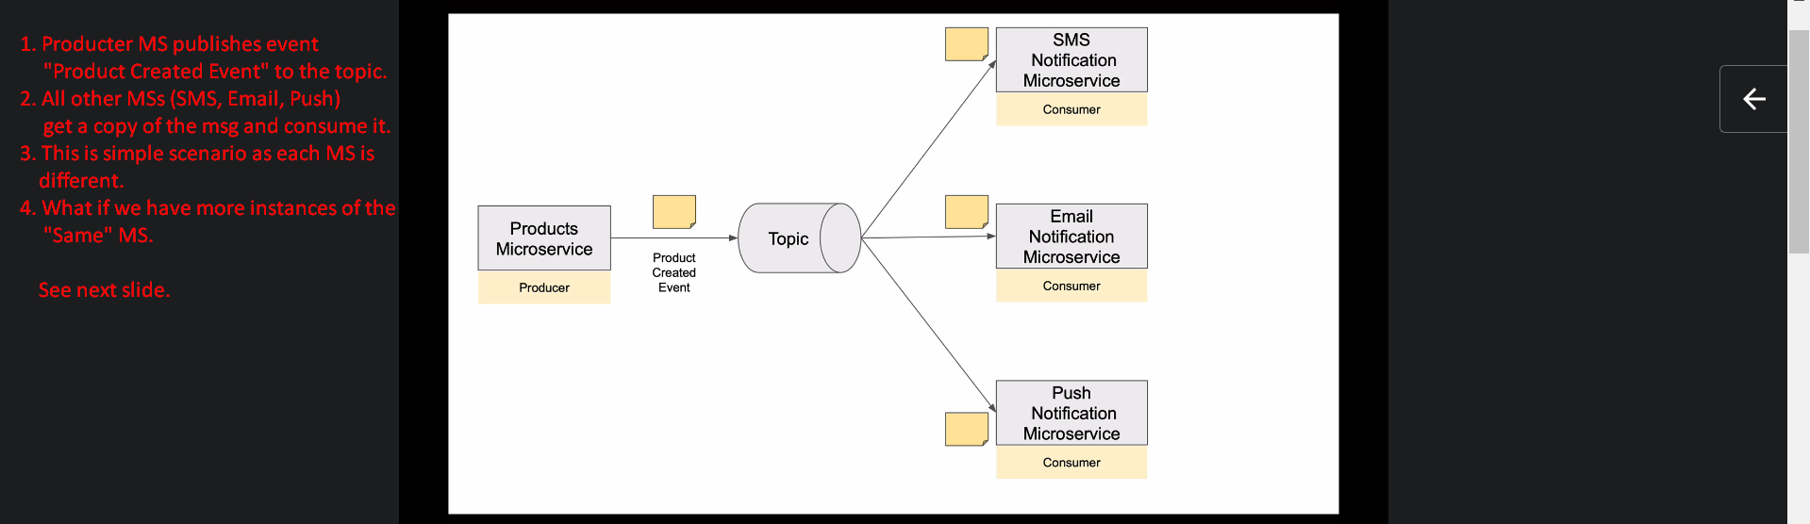
4. 
5. 